Just-In-Time Report
October 2021
PY21 Issue 4

Prepared by:
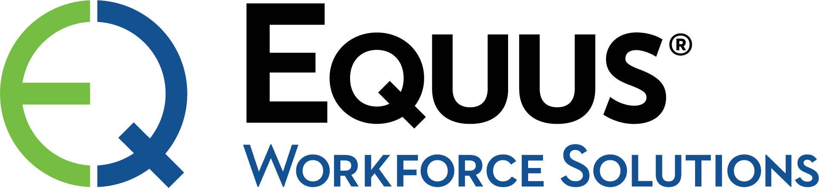

SC Works Upstate

Cherokee
Spartanburg
Union
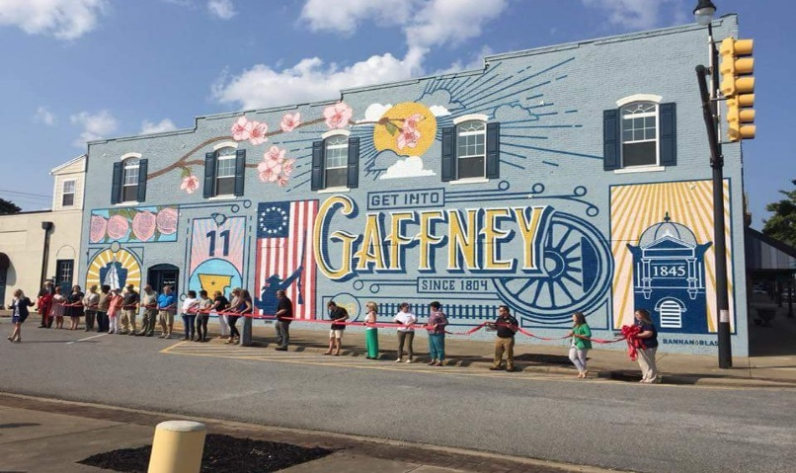
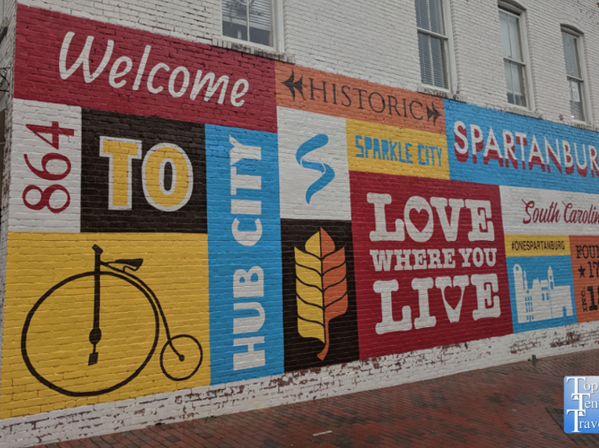

SC Works Upstate Traffic, WIOA Orientation, WIN, and Workshop Data
WIOA Orientation Attendance:

14 (virtual)
Workshop Attendance
51 (virtual)
WIN Testing
Spartanburg – 8
Center Traffic:

Month- 979
PY21- 5,839

Unemployment Rates Sept. (or latest available) (*not seasonally adjusted)
US | South Carolina | Spartanburg | Union | Cherokee | Veterans
4.8 | 4.1 | 3.2* | 5.4* | 4.1* | 3.6
Center | SCWOS Job Referrals - Staff | Internet (self)
Cherokee | 335 | 163
Spartanburg | 1,585 | 1,239
Union | 298 | 104
Customer Satisfaction Survey
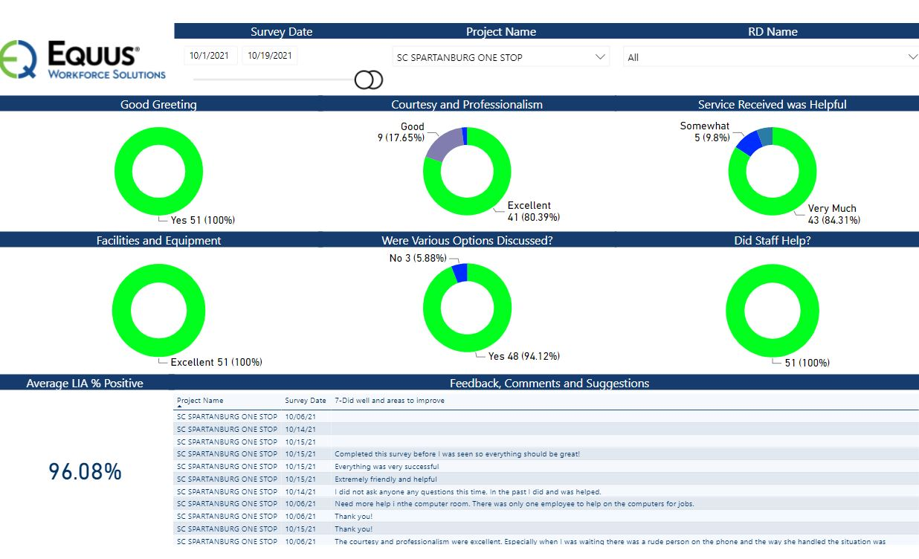
Business Partner Surveys (Latest Available-September 2021)
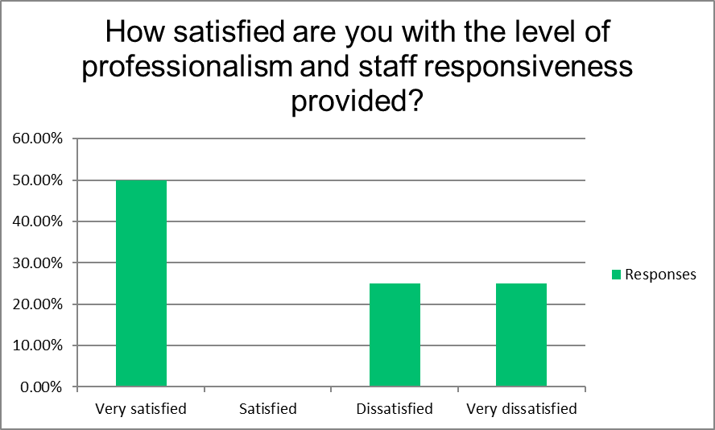
How satisfied are you with the level of professionalism and staff responsiveness provided?
Answer Choices Responses
Very satisfied 50.00% 2
Satisfied 0.00% 0
Dissatisfied 25.00 1
Very dissatisfied 25.00 1
Answered 4
Skipped 1
Total Satisfied= 50.00%
RECRUITMENT EVENTS: October 2021
Events Jobseekers
8 222

Training & Support Services Funding PY21

Enrollment Data Cumulative PY21
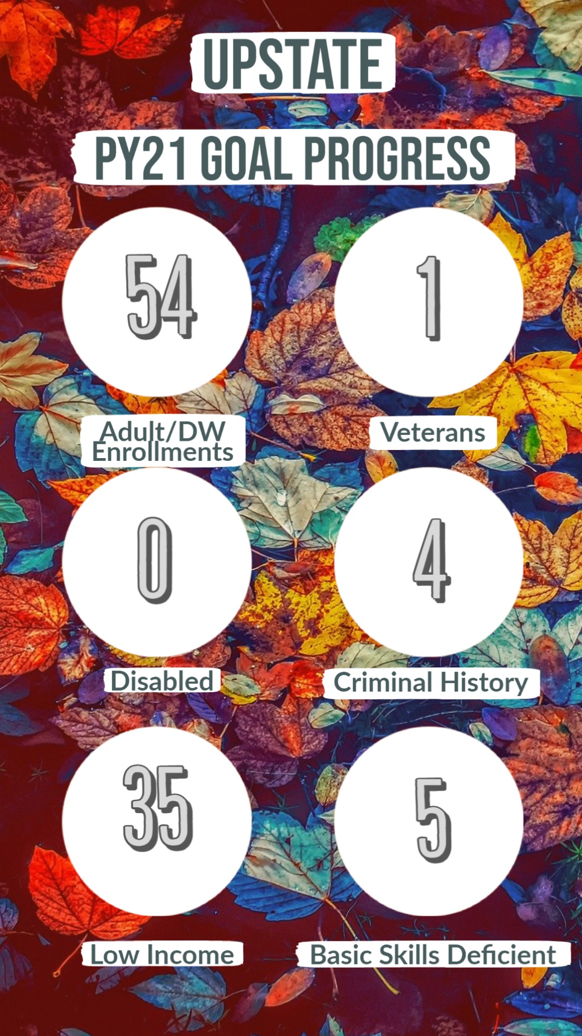
Priority of Service Rate (at end of month) = 88% (45 of 51)

Enrollment Data October
Center | New Trainings | Enrollments AD | Enrollments DW
Union | 1 | 3 | 0
Cherokee | 1 | 4 | 0
Spartanburg | 2 | 6 | 0

Work-based Learning (OJT/WEX)
October WBL: 1 | WBL YTD: 10 Goal PY21: 40
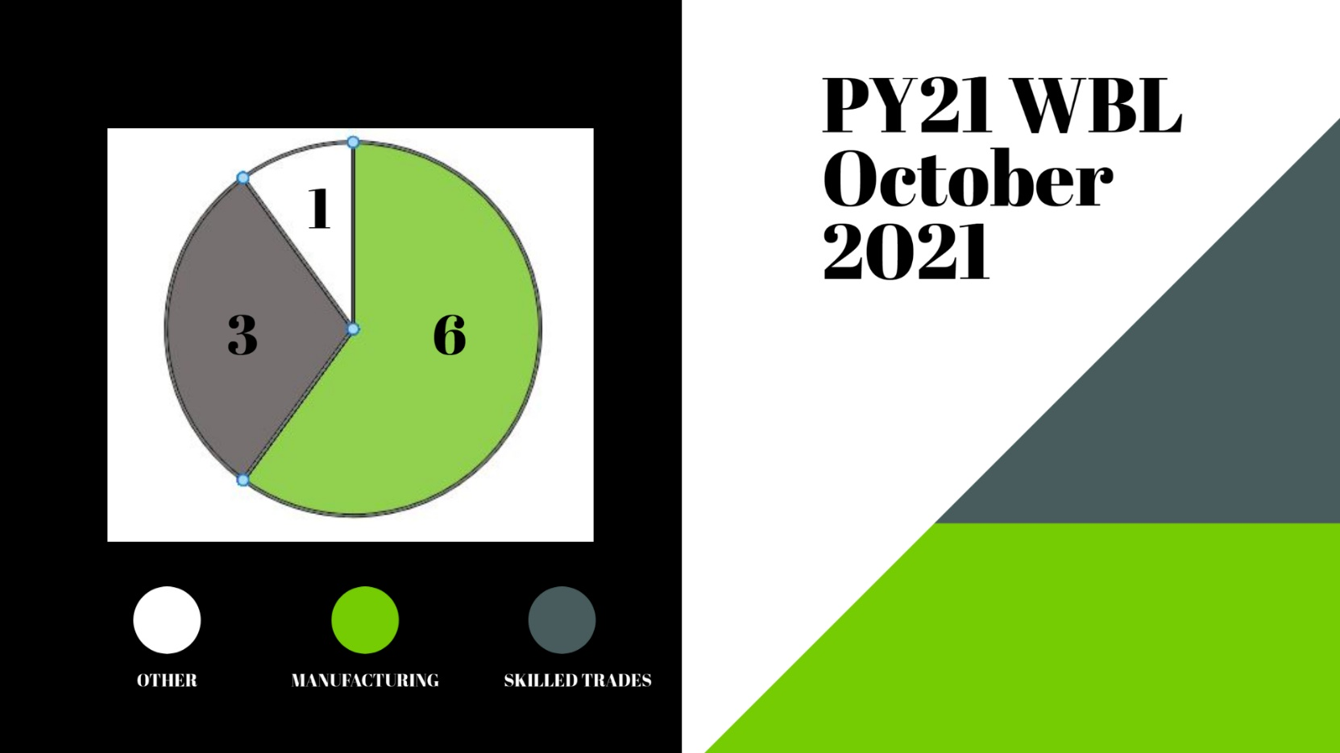

Training Target Sectors
Training Target Sectors | Number In Training | Percent | Goal
Manufacturing | 7 | 24% | 20%
Trades / Const. | 3 | 10% | 15%
Logistics | 14 | 49% | 15%
Other | 5 | 17% | 50%

Social Media

Social Media Outreach (Cumulative):
152 Posts and 177 Facebook Likes
PY21 Goal - 252 Posts and 200 Likes

Community Engagement

Events Attended:
Spartanburg- 27
Cherokee- 15
Union- 16

Social Media Spotlight
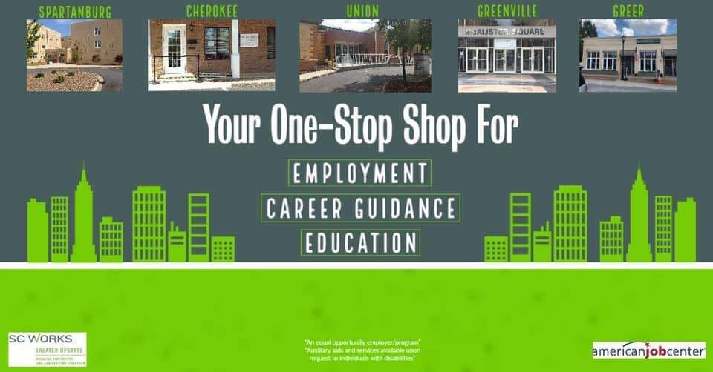
Equus Team Focus / Outreach

Equus Team / Outreach
On October 22, the SC Works Greater Upstate team completed its quarterly training. This quarter we focused on equal opportunity sensitivity training, the veteran’s intake process, and Job Corps. It was a great opportunity to learn together and see everyone across the region.
SC Works Upstate held 8 hiring events in October, including a large multi-employer job fair on October 21. Through these events, we were able to serve 222 job seekers!
SC Works will be closed November 11 for Veteran’s Day. Equus staff will complete training in Spartanburg that day.
Kenneth participated as a vendor at the Career Fair for students attending Boiling Springs High School. He was able to speak with several students about On the Job Training Opportunities after graduation.

Kenneth and Mary Beth attended a virtual training session on Essential Basics for a Board Member with a Non-Profit Organization. The training covered the financial, leadership, and accountability aspects of guiding a non-profit.

Jocelyn attended Union County Partner Meeting. Executive Director Christina McDowell presented information on Healthy U Behavioral Health Services. Timika Wilson with CPST Outreach Team presented information on the Capital Project Sales Tax Information.

Kenneth met with Libbie Cheek at the Non-Profit Center in Gaffney to discuss various community programs in Cherokee County. Libbie spoke about the Foodshare Program in the Upstate and how it impacts Cherokee County. Kenneth spoke about the Oculus Headsets and how they could be utilized in Cherokee County.

Kenneth attended a Zoom Meeting to discuss the progress the Litter Hero participants have made in this program. The group also discussed the upcoming graduation ceremony for the participants, as well as their progress in obtaining new employment in November.

Mary Beth participated in the WBL workforce development council meeting for the month.

Kenneth attended the Health and Wellness Event in Cherokee County held on Saturday October 23rd.

Johnnie Lynn presented at the Regional Workforce Advisors board meeting - AR project.

Nikki attended the monthly Disabilities and Special Needs Board meeting.

Success Story: Samuel
Samuel attended the Workforce Innovation & Opportunity Act (WIOA) Information Session in August of 2020 seeking to gain a new skill during the COVID-19 Pandemic. He was enrolled into the WIOA program shortly afterwards and explained that he was seeking welding training. He felt that welding was an in-demand occupation that would provide him with stable employment, an excellent income, and a long-term career.
Based on the discussion with him, an Individual Employment Plan (IEP) was created to build a roadmap to achieving his goals. He completed a series of Career Readiness Workshops with SC Works Greater Upstate as well as the WIN Assessment to help prepare him for the new labor market upon graduating. He began welding training with Norris Mechanical in January of 2021.
He successfully completed his welding training a few months later in April and earned three (3) certificates in the field. He started his new career as a welder in May of 2021. Congratulations Samuel!
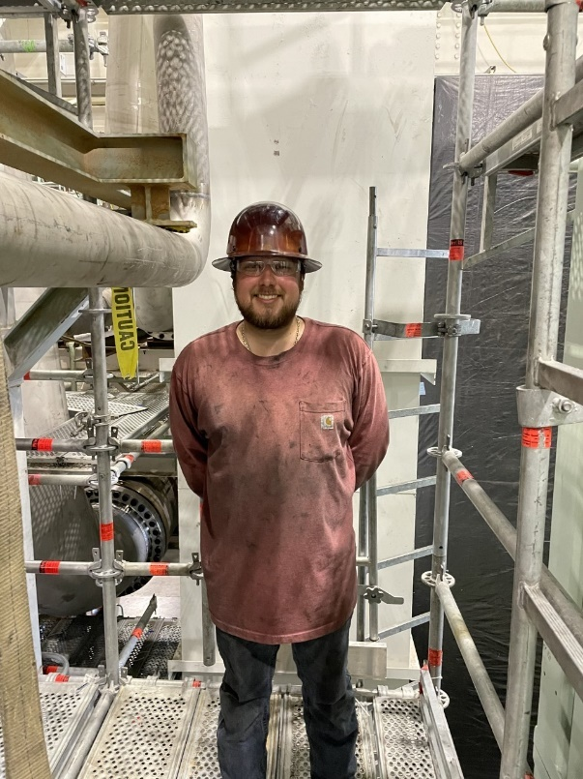

*The mission of the SC Works Greater Upstate system is to establish and continuously improve an accessible, seamless, and customer-focused one-stop delivery system in Cherokee, Spartanburg, Union, and Greenville counties by assisting employers, jobseekers, and those seeking other workforce or community related services.

